EXERCISE 1(Basic Unit Test for a Service Method)

package com.example.demo.service;  
  
import org.springframework.stereotype.Service;  
  
@Service  
public class CalculatorService {  
 public int add(int a, int b) {  
 return a + b;  
 }  
}

package com.example.demo.service;  
  
import org.junit.jupiter.api.Test;  
import static org.junit.jupiter.api.Assertions.*;  
  
class CalculatorServiceTest {  
 @Test  
 void testAdd() {  
 com.example.demo.service.CalculatorService calculatorService = new com.example.demo.service.CalculatorService();  
 int result = calculatorService.add(5, 3);  
 *assertEquals*(8, result);  
 }  
}

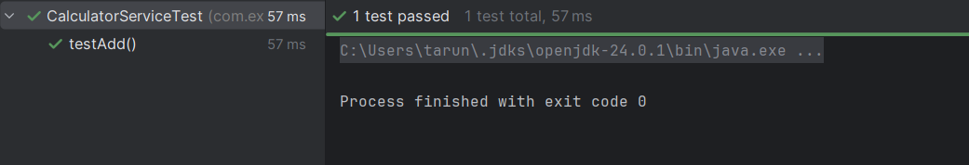OUTPUT

EXERCISE 2(Logging Error Messages and Warning Levels)

package com.example;  
  
import org.slf4j.Logger;  
import org.slf4j.LoggerFactory;  
  
public class Main{  
 private static final Logger *logger* = LoggerFactory.*getLogger*(Main.class);  
  
 public static void main(String[] args) {  
 *logger*.error("This is an error message");  
 *logger*.warn("This is a warning message");  
 }  
}

OUTPUT

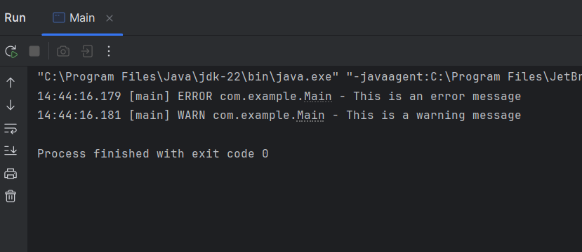

EXERCISE 3(PARAMETERIZED LOGGING)

package com.example;  
  
import org.slf4j.Logger;  
import org.slf4j.LoggerFactory;  
  
public class Main {  
  
 private static final Logger *logger* = LoggerFactory.*getLogger*(Main.class);  
  
 public static void main(String[] args) {  
 String user = "TARUN";  
 int age = 20;  
 *logger*.info("User {} has logged in.", user);  
 *logger*.warn("User {} is {} years old - verify age!", user, age);  
 *logger*.error("Login attempt failed for user: {}", user);  
 }  
}

OUTPUT

